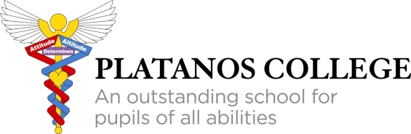

SUPPLEMENTARY INFORMATION FORM (SIF)

PLEASE COMPLETE AND RETURN THIS DIRECTLY TO THE SCHOOL BY:
FRIDAY 13 OCTOBER 2023
(PLEASE NOTE: OUR DATE IS DIFFERENT TO THE LAMBETH DEADLINE)
RETURN ADDRESS: Admissions, Platanos College, Clapham Road, London, SW9 0AL
Please note you must also submit a Common Application Form (CAF) to your home local authority if you wish to apply for a place at Platanos College.
Childs forename: |  | Childs surname:
Childs date of birth: / / |  | Childs gender: Male Female
Home address:

Post Code:
Borough of residence:
Child’s current school and address:

Name of Parent(s)/Carer(s):
Mr/Mrs/  Ms/Miss | First Name: |  | Surname:
 | Mobile number: |  | Telephone:
Mr/Mrs/  Ms/Miss | First Name: |  | Surname:
 | Mobile number: |  | Telephone:

Is the child under the care, or have previously been under the care, of the  Local Authority? (A ‘Looked After Child’) | No |  | Yes |  | If yes, supporting evidence attached  (please tick)
Is any one of the parent/carers a member of staff at the school? |  |  |  | No |  |  | Yes

Is a sibling (or siblings) currently on roll, and will still be on roll next September, at Platanos College?
If yes, please provide the following information:

Name of sibling(s): Tutor group: Date of birth:

Scholarships
Platanos College offers designated places (up to 16) for pupils who show aptitude and potential in Art or Music. The school will make scholarships available for successful applicants.

Are you applying for an Art or Music Scholarship? | Yes |  | No

If yes, please tick all relevant subjects: | Art |  | Music

- Please note that the applicant will need to be able to demonstrate aptitude and potential by completing the separate Scholarship Application Form (available from the school office and school website). This form must be returned directly to the school.
- The child will also be invited for an interview at a later date decided by the school where the child will have the opportunity to demonstrate their aptitude (e.g. present an art portfolio or play a musical instrument). Please see Appendix A for further information.

Admissions Test Information

Platanos College shares Admissions Test arrangements with the schools below. All nine schools hold the same Admissions Test. We aim, in this way, to limit the number of tests children are required to sit.

If you are applying to any of the following schools, your child will only need to sit the Admission test once.  Please indicate the school at which you would like your child to sit the test (tick one box only). |  | Platanos College  Norwood School  Dunraven  Lilian Baylis

Your child must only sit the test once, at one school only. Please tick only one box indicating where you would like your child to sit the test. You must send the SIF form directly to the school you wish your child to sit the Admissions Test. If you fail to submit a Supplementary Form (SIF) directly to the school at which you wish to sit the test, your child may miss the Admissions Test day. Once the test results are known the admissions departments collaborate in sharing the test scores with each of the schools for admissions purposes only.

No Supplementary Forms will be accepted after the deadline at the top of this form.

To apply for a place, please also remember to complete and submit the CAF to your Local Authority. Please note the CAF completion deadline is different to ours. The CAF form is obtained and completed online via your Local Authority website.

Declaration
I understand that any false or deliberately misleading information provided in this application may make this application invalid or lead to any offer of a place being withdrawn.
Parent/Carer signature: | Date:

